**OreSat Deployable Antennas**

*Concept Analysis*

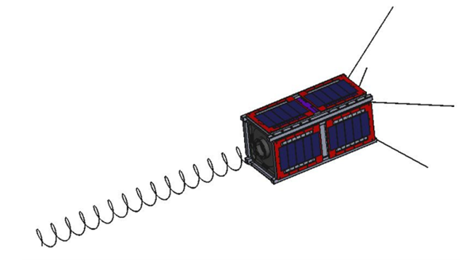

**Team Members**

*Calvin Young*

*Shivani Nadarajah*

*John George*

*Paijanne Jones*

*Justin Burris*

**Sponsors**

*Andrew Greenberg*

*Glenn LeBrasseur*

**ME 492**

*Gerald Recktenwald*

*26 January 2018*

**Due Date**

*Wednesday, February 28*

**Project Objective**

Design, manufacture and validate two antenna systems, a canted turnstile array and a directional helical antenna, for a 2U cubesat (Oresat) for less than $2000. Both systems will be stowed for up to six months, and then deployed into Low Earth orbit approximately 45 minutes after launch from the International Space Station.

**Project Architecture**

The OreSat requires two separate antennas to accomplish its primary mission to communicate with ground receivers. The first antenna, a turnstile array, consists of four monopoles fixed at 90 degrees; each pole will be canted between 15 and 60 degrees from the ground plane. This antenna transmits an omnidirectional signal, which enables initial contact with the ground station, then receives commands for satellite control.

The second antenna will be a high gain, s-band helical. This highly directional antenna will be used to stream video from the satellite cameras to the ground stations. This antenna spring will be fabricated by wrapping wire around a mandrel to plastically deform it. It will be mounted, compressed, and stowed until the deployment using a retaining cap and a nylon monofilament wire.

For storage, the four poles of the turnstile array will be rolled into the antenna mount so that they spring back to their original orientation upon deployment. A guide ring, or similar part, may be used to help orient the stowed antenna poles.

The block diagram in figure 1 depicts all main parts of the antenna systems and their general orientation. The deployment mechanism shown in red on each antenna is responsible for constraining the springs as well as releasing them.

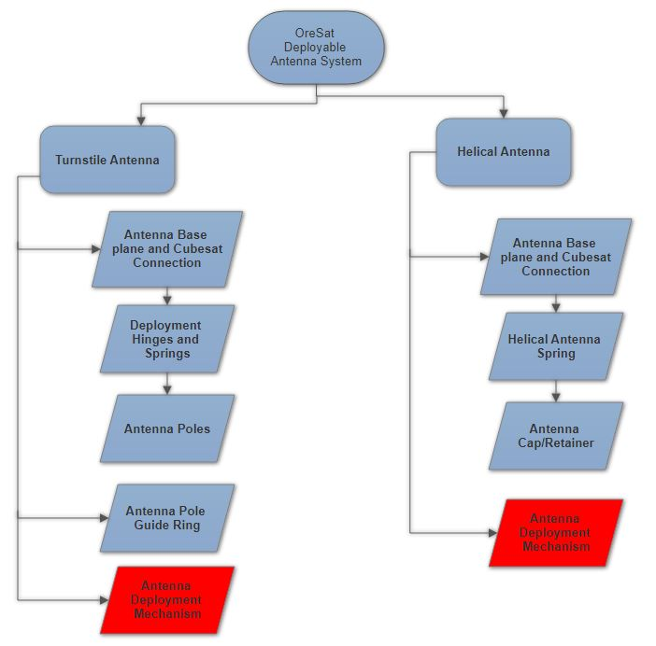

**Figure 1**: Structural Decomposition block diagram highlighting the system architecture

**Subsystem Under Consideration**

It can be seen from figure 1 that the deployment subsystem is most critical; both antennas depend on it for successful operation. If this subsystem malfunctions, the satellite will be unable to communicate with the ground receivers which is OreSat’s primary objective.

The deployment subsystem must restrain the antenna springs under load for an extended period of time and through multiple environments. These environments include shipping to the testing and launch facilities, as well as enduring intense flight conditions. The cubesat will then be dispatched from a Nanoracks system onboard the International Space Station and after a specified time delay, the antenna deployment mechanisms must trigger. For power, the system will have access to a low current, 3 volt power supply. The customer has emphasized a “no failure acceptable” approach as there will only be one opportunity for final deployment into orbit.

The team is expected to complete thorough simulations and validation testing for all systems including the antenna deployment. The team’s work must be complete by the end of Spring term since the system must be sent to NASA for evaluation and eventual launch in roughly 18 months.

**Analysis**

Through group brainstorming and thorough research, four concepts for the deployment mechanism have been identified. Sources that were explored for possible deployment mechanism concepts include NASA documents and antenna design textbooks. The first concept is a spring-loaded nichrome burn wire system developed and used by the Jet Propulsion Laboratory. This design involves manufacturing all parts from scratch including travel pins, mounting brackets, springs and base plates. The concept of the design is that the nichrome wire is heated by applying current to the wire. The compression springs are then triggered and pull the heated nichrome wire through the restraining vectran tie down in a cutting motion allowing the antenna to deploy.

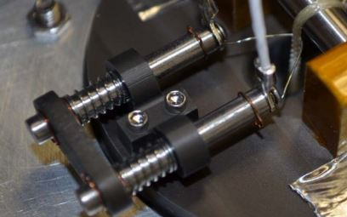

**Figure 2:** Assembled spring-loaded nichrome burn wire system (<https://www.nrl.navy.mil/PressReleases/2014/AMS%20Paper%20-%20A%20Nichrome%20Burn%20Wire%20Release%20Mechanism%20for%20CubeSats%20-%20Final%20-%20Adam%20Thurn.pdf>)

The next concept identified involves using the spring properties of the antenna systems themselves to maintain tension on a nylon monofilament line. This nylon line prevents the systems from deploying and a one ohm resistor is oriented in such a way that the tension in the line keeps it in contact with a 1 ohm resistor. This resistor is then heated similarly to the nichrome wire in the first concept causing the nylon to fail. Although exact heating achieved by the resistor is currently unknown, exploratory tests have been conducted to ensure it will achieve the heat required and cause the nylon monofilament to fail. Further testing is required.

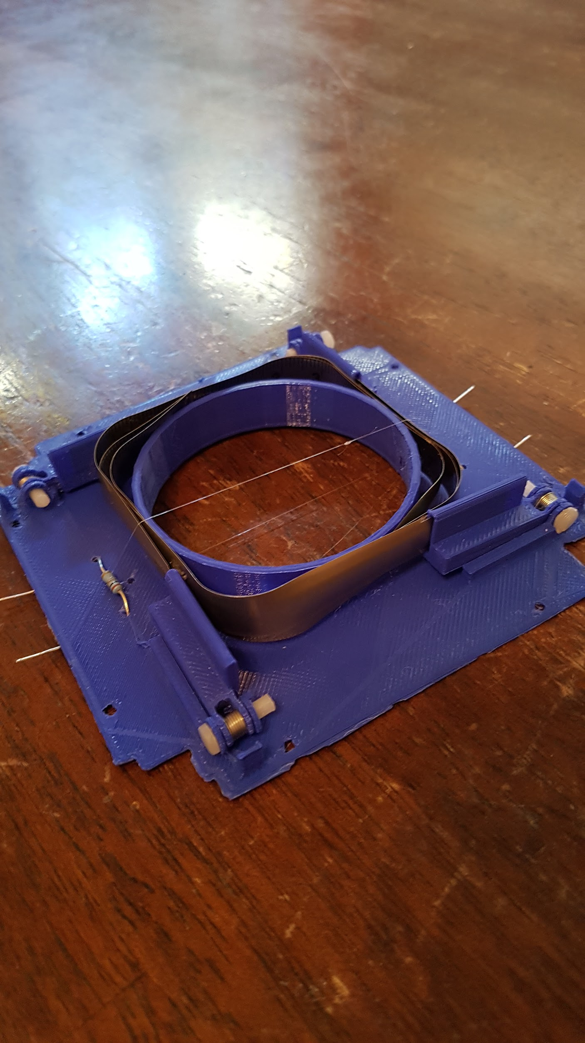

**Figure 3:** Tension loaded resistor burn wire design

By combining the two previous concepts, a third design was created. Replacing the resistor with a nichrome wire, greater design flexibility can be achieved by controlling the length and diameter of the nichrome wire. In manipulating these dimensions, the resistance of the wire can be changed and in return, the heating rate and power consumption can be changed. To confirm requirements will be met by this design, the heating rate through electrical resistance can be modeled by the following equation:

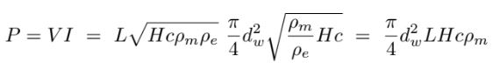

(1)

Reasonable values were chosen to confirm the range of heating that could be achieved was possible with this design. An example calculation is below:

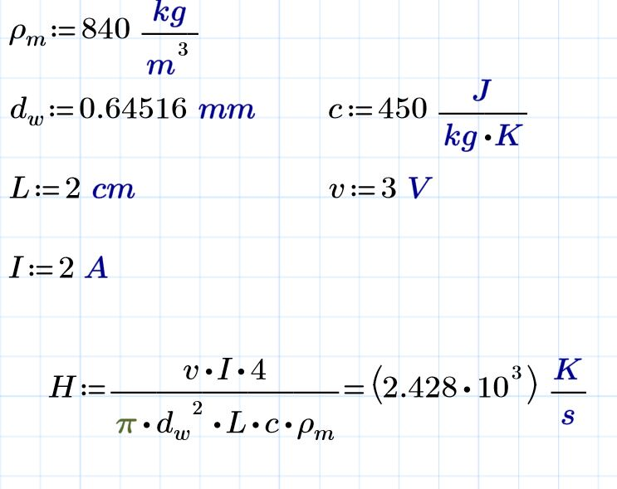

From this calculation, it can be seen that the heating rate is more than sufficient to reach the maximum melting point of nylon(350C) within one second at these reasonable values for wire length and diameter.

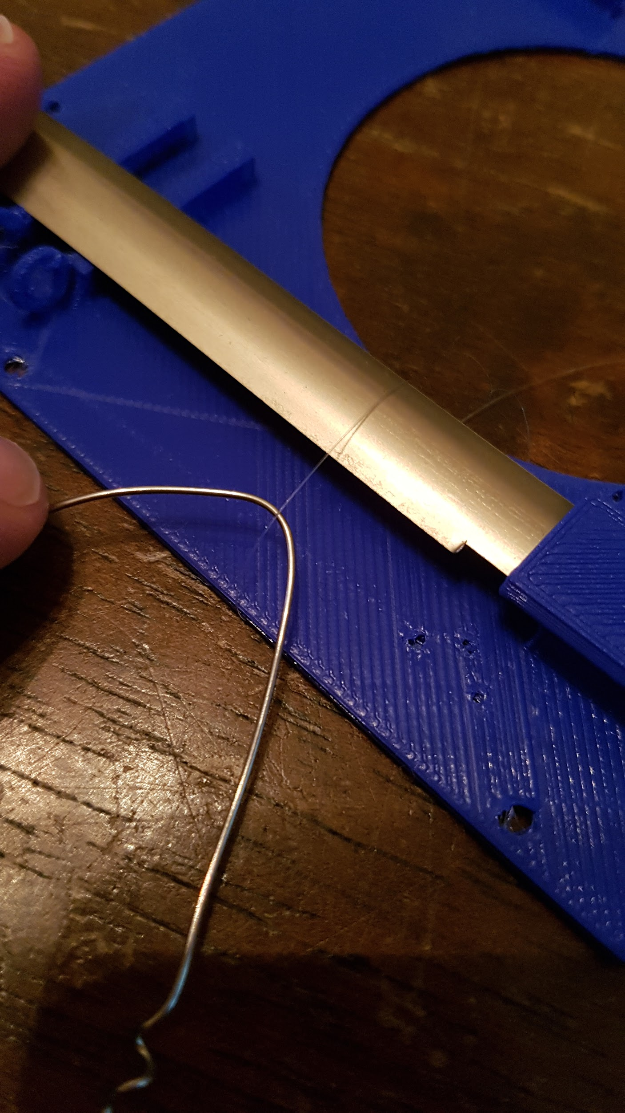

**Figure 4:** Tension loaded Nichrome burn wire design

The fourth and final concept considered in this conceptual analysis was some form of motor driven release mechanism. A retaining pin would be positioned to hold the stowed antenna systems in position until deployment. Upon deployment command, the motors would trigger, moving the retaining pin and allowing the springs to extend. Micro stepper motors, as seen in figure 5, seemed to fit our applications the best.



**Figure 5**: Micro stepper motor for use in possible mechanical release system

Alternatives to these designs that were considered include a solenoid release system, electromagnetic deployment, hydraulic and pneumatic systems but all were deemed not feasible due to dimensional constraints, power budget restraints or weight concerns. To evaluate the four different designs, a Pugh Matrix was created using the four criteria deemed most important on this subsystem. Cost, size, reliability and manufacturability/adjustability.

**Table 1:** Pugh Matrix showing weighted criteria scores for possible design concepts

|  |  |  |  |  |  |  |  |
| --- | --- | --- | --- | --- | --- | --- | --- |
| Criteria |  | Baseline | Weight | Conceptual Designs | | | |
|  |  |  |  | Existing Spring-Loaded Nichrome system | Tension Loaded Resistor | Tension Loaded Nichrome | Motor Driven Mechanical Release |
| Cost |  | 0 | 2 | -2 | 2 | 2 | -2 |
| Size |  | 0 | 4 | 0 | 4 | 4 | -4 |
| Reliability |  | 0 | 5 | 5 | 5 | 5 | 0 |
| Manufacturability/Adjustability |  | 0 | 2 | -2 | -2 | 2 | -2 |
|  |  |  | Score | 1 | 9 | 13 | -8 |

**Conclusion**

Considering the pugh matrix, the motor driven mechanical release design is immediately removed due to its poor scoring in size, cost and manufacturability. The spring loaded nichrome wire design can also be eliminated due to its considerable manufacturing complexity and prohibitive cost. Although the tension loaded nichrome scored the best, both tension loaded resistor and tension loaded nichrome wire designs will be pursued and tested in different environmental conditions to determine the best configuration. A functional decomposition of these designs was also created to further conceptualise the requirements of these systems. This can be found in the appendix. The team will need to design experiments to validate and refine the performance of these designs including testing in a microgravity environment and in a vacuum. This will be the focus of a formal mechanical engineering report the next few weeks.

**Appendix**

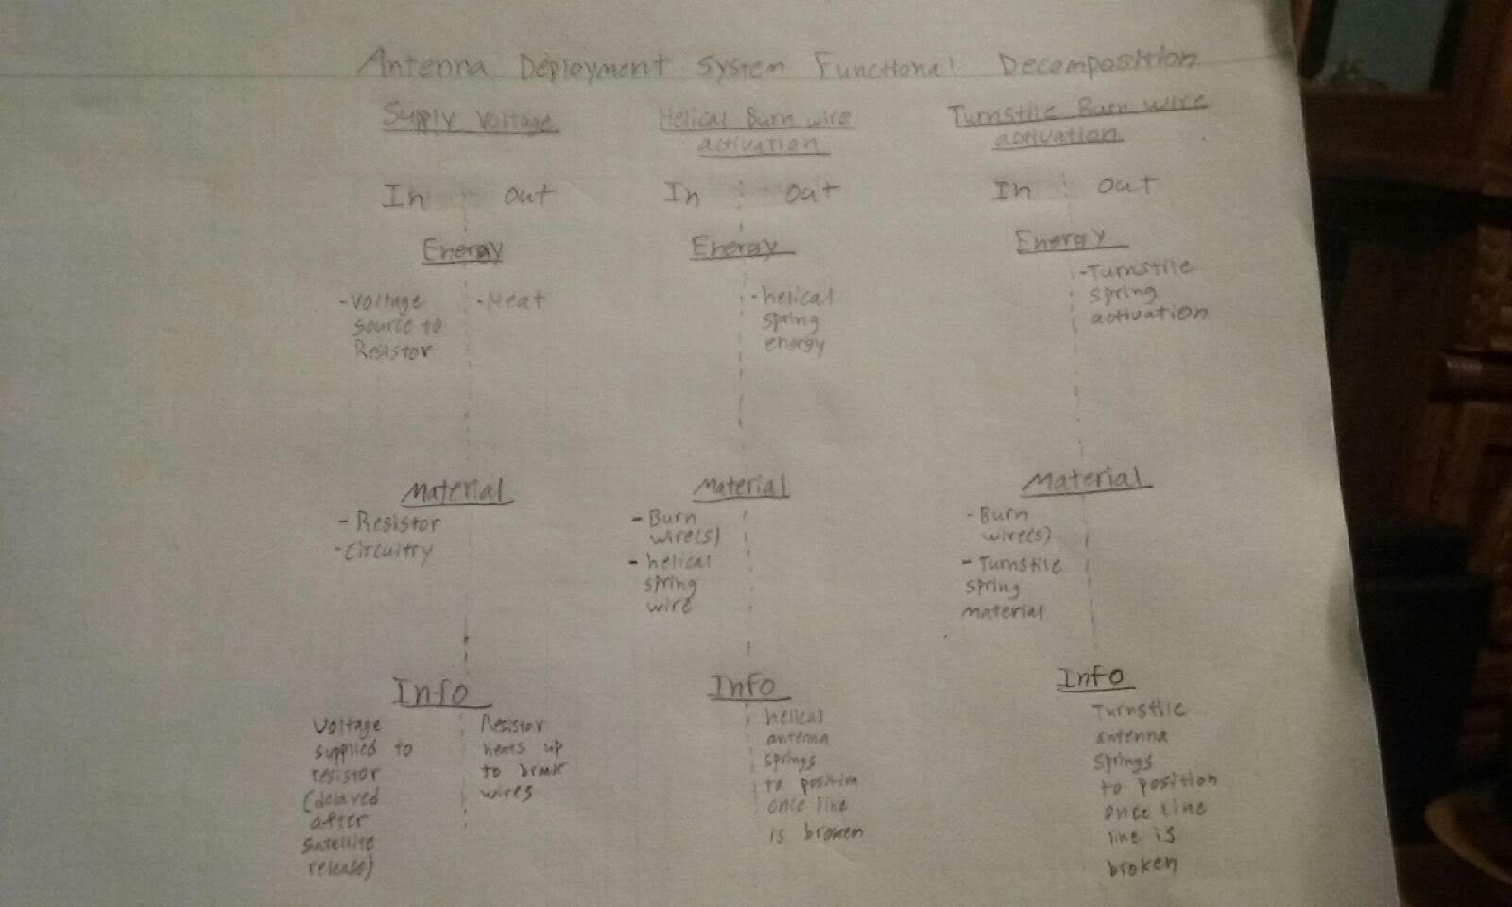

**Figure 6:** This functional decomposition of the burn wire sub system shows energy in and out, material components under consideration and information about three functions of the deployment system.